If Buhari Does Not Kill Corruption It Will Kill Buhari
- News
- Sports
- Africa
- World
- Opinions
- Politics
- Business
- Diaspora
- Entertainment
- LifeStyle
- Real Estate
- Classifieds
- Media
- Members
Press Release | 8 February 2017 23:11 CET
0 Comment

EFCC Arraigns Four for $1m Fraud
By EFCC
Previous | Next
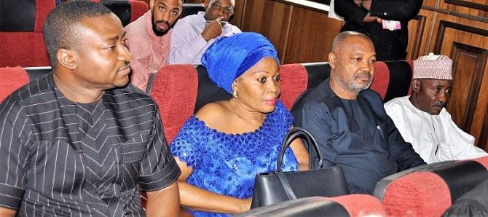
The Economic and Financial Crimes Commission, EFCC, on Wednesday February 8, 2017 arraigned the quartet of Umar Audu Bida, Truth Igogori, Ifenyinwa Nwankwesiri and Ogechukwu Obaji before Justice Binta Nyako of the Federal High Court sitting in Maitama, Abuja on a 9-count charge bordering on conspiracy, forgery and obtaining by false pretence to the tune of $1million (One Million US Dollars).
The accused were arraigned alongside four companies: Universal Contractors, Lambda Energy Services Limited, Double Wonder Concept Limited, and ICS Energy Services Limited.
Bida and his co-accused sometime in 2014 allegedly conspired to defraud one Donald Latella of North Park LLC of $1million under the pretext of supplying about two million barrels of Bonny Light Crude Oil.
The offence contravenes Section 8 (b) of the Advance Fee Fraud and Other Fraud Related Offences Act, 2006 and punishable under Section 1 (3) of the same Act.
Count 2 of the charge reads:
"That you, Umaru Audu Bida, Truth Igogori, Ifenyinwa Nwankwesiri, Ogechukwu Obaji, Universal Contractors, Lambda Energy Services LTD, Double Wonder Concept Limited, and ICS Energy Services Limited and others now at large, sometime in 2014, within the Judicial Division of the Federal High Court of Nigeria attempted to obtain the sum of $1,000,000.00 (One million United States Dollars) from Donald Latella of North Park LLC under the false pretence of supplying about 2 million Barrels of Bonny Light Crude Oil which you knew to be false and thereby committed an offence contrary to Section 8 (b) of the Advance Fee Fraud and Other Fraud Related Offences Act, 2006 and punishable under Section 1 (3) of the same Act”.
The accused persons pleaded not guilty to the charge.
Upon their plea, counsel to the EFCC, Onjefu Obe, asked the court for a date to present his witnesses and for the accused to be remanded in prison custody pending trial.
However, Ammeh O. Ammeh representing 1st and 5th defendants and R. O. Attabo standing for 2nd, 3rd, 4th, 6th, 7th and 8th defendants, through oral applications prayed the court to admit their clients to bail.
Justice Nyako held that the court was a court of record and asked the defence to make their applications formal.
The judge, thereafter, adjourned to Thursday, February 16, 2017, for hearing of the bail applications and ordered that the accused persons to be remanded in prison custody.
Wilson Uwujaren
Head Media & Publicity
8th February, 2017
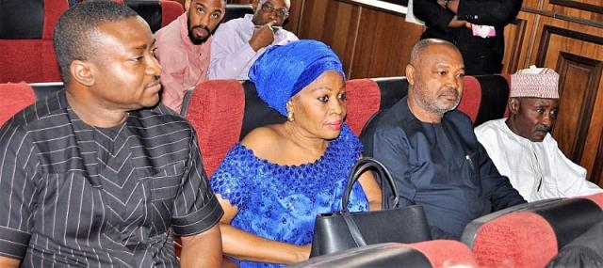
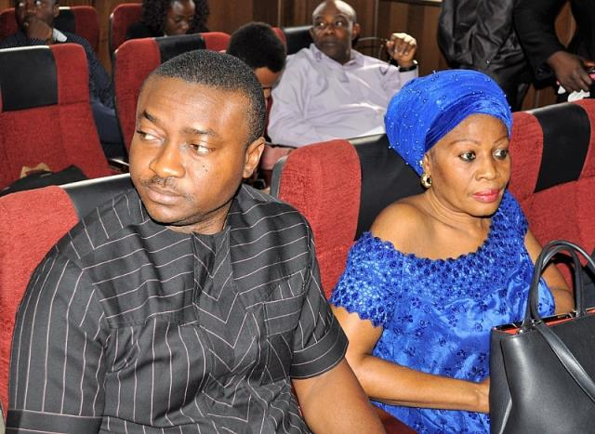
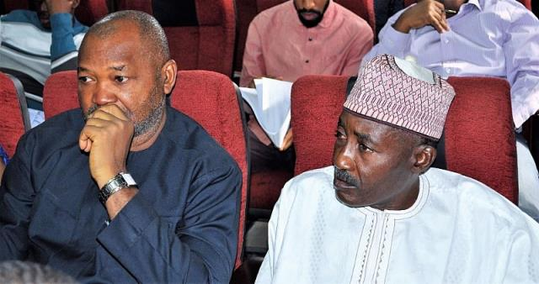
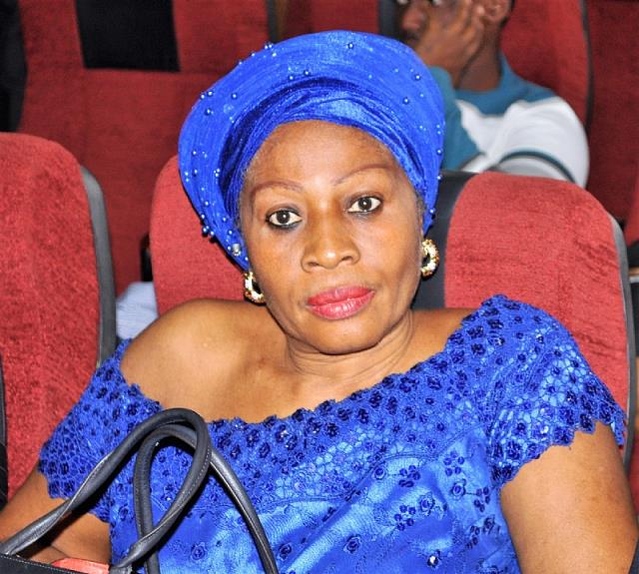
Dr. Ifenyinwa Nwankwesiri
Ogechukwu Obaji
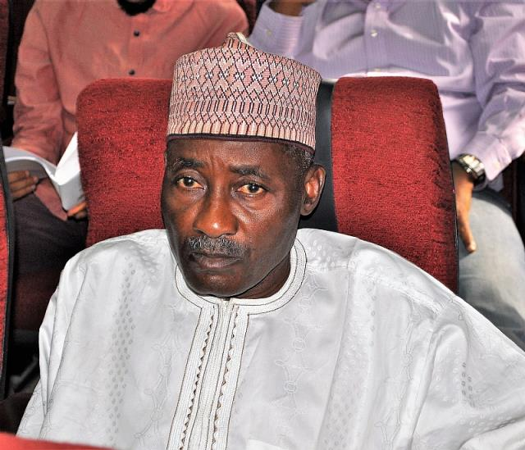
Umar Audu Bida

